Game Theory for Rebels
A Guide for the Oppressed

Part III

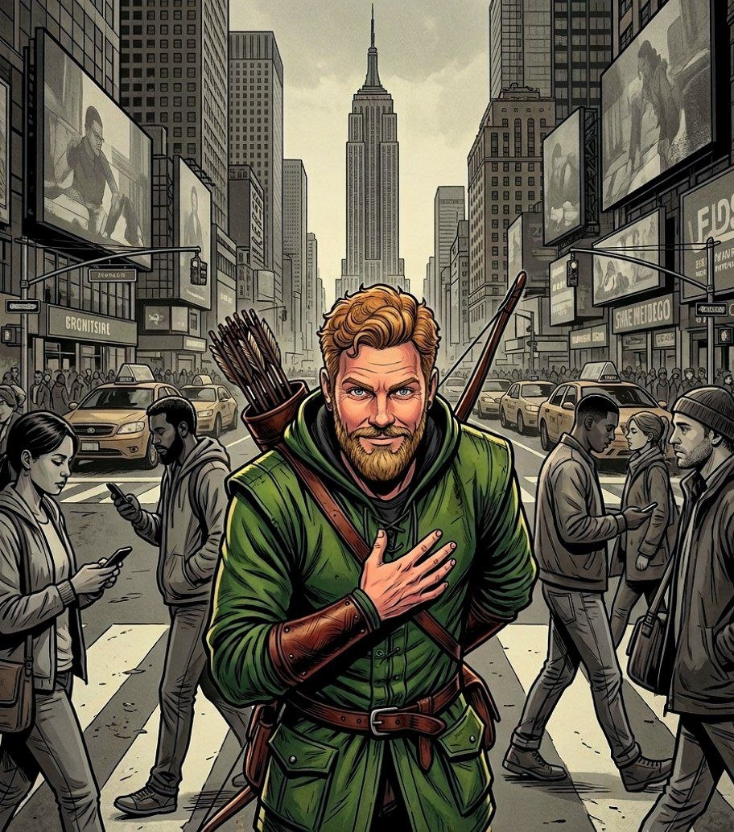

Ropes Pierre

Game Theory for Rebels
A Guide for the Oppressed

Part III

By Ropes Pierre

Published by:
The Swarm of Strategic Rebels
who Volunteer to share this document.
Copyright Notice (CC BY 4.0)

This work is released into the public domain under the Creative Commons Attribution Licence (CC BY 4.0). You are free to copy, distribute, and adapt this work, on condition that any derivative works or reproductions must properly name and credit the original source/author.

Since the author is anonymous, appropriate credit specifies where the author posts his philosophical work, more specifically https://thepragmaticrealist.substack.com/, and can be in several forms such as:

- "The Pragmatic Realist (Substack)", with or without hyperlink.
- "thepragmaticrealist.substack.com", with or without hyperlink.
- "Ropes Pierre", with hyperlink to Substack or the address displayed.
- "Ropes Pierre via The Pragmatic Realist (Substack)", with or without hyperlink.

Game Theory for Rebels 3: Political Choices and Democratic Betrayals

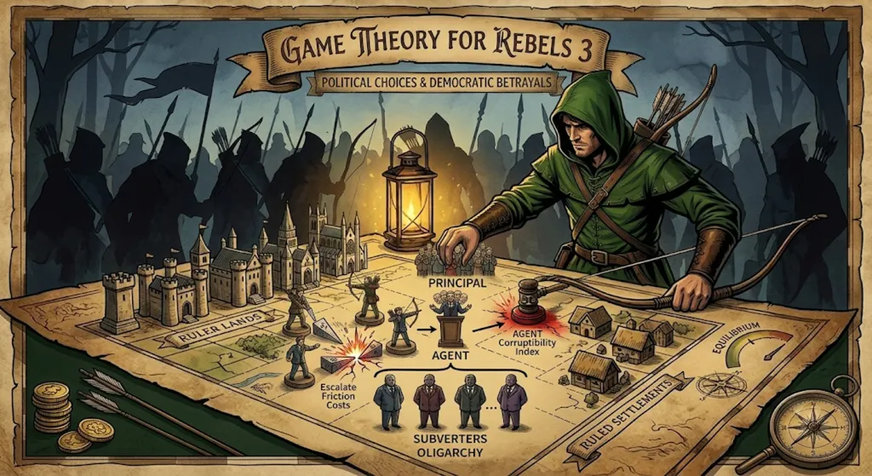
The previous section established some baseline tactical considerations for any Rebel movement pushing back against an oppressive regime. We will now introduce some economic theory to explain the franchises that politicians establish with their voters, and with their Subverters.
Game Theory for Rebels 3 is an exploration of the incentive structures in democratic politics, based on Public Choice Theory. We will also adapt the Discounted Cash Flow equation from Economics, which measures the future value of a business or franchise as an indicator for investment decisions, to explain the dynamics of a political Problem Franchise and a political Corruption Franchise.
A Problem Franchise is a portfolio of public interest problems that a Political Camp or a Political Brand exploits in order to extract utility from the voters. A Corruption Franchise is a portfolio of private interest problems that a political camp or brand exploits in order to extract utility from the Subverters. The Utility of a franchise is either measured in ability to gain votes, or the ability to draw in cash flows.
We will then expand the Principal-Agent Model into a Principal-Agent-Subverter Model, examine the Median Trade-Off between organic votes and Subverter capital, and then move into a Multi-Subverter Model to explain why politicians maintain these two franchises, and what can be done to undermine oligarchical collusion.
Ultimately, this chapter provides a diagnostic map of the existential vulnerabilities of a politician, a Political Brand, or a Political Camp. For the Strategic Rebel, the goal is not to try and smash these structures through brute force. Rather, by understanding the hidden mathematical mechanisms underlying their incentives, we can identify exactly how to attack those incentive structures, with the ultimate aim of lowering the Agent Corruptibility Index and maximising the Risk of Democratic Betrayal.
This section has many mathematical formulae, which should not intimidate you if you are not familiar with maths. For each equation, I will clearly explain what the implications are for a Strategic Rebel movements.
If you are capable of understanding the maths, then please treat this as a lesson in how to apply statistical methods (score keeping) to the study of the Game’s mechanics.

Public Choice Theory:
The Myth of the Benevolent Politician

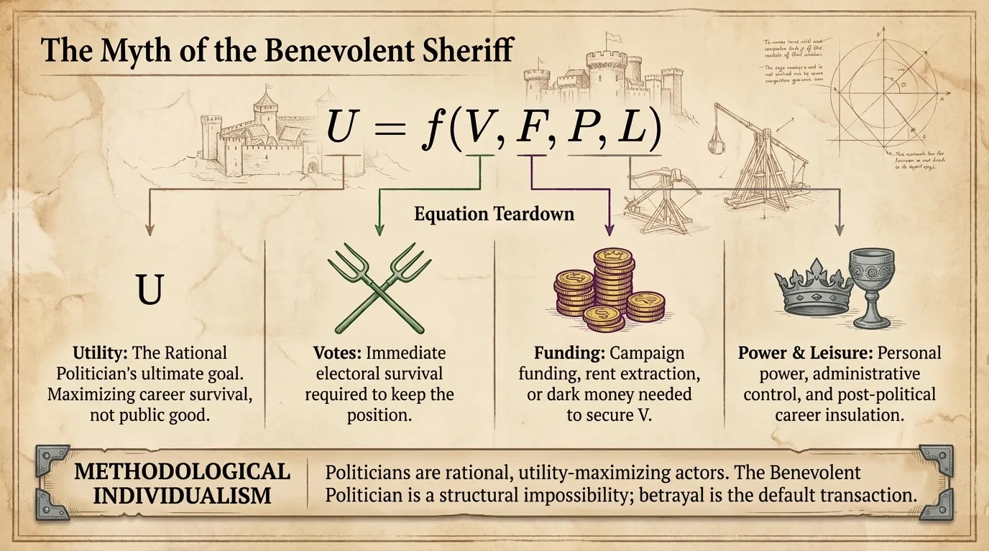
Since childhood, we are taught to believe that political actors are uniquely selfless agents who want to work for the benefit of society. To understand Political Choices and Democratic Betrayals, we must first abandon our romantic assumptions about Benevolent Politicians.
Public Choice Theory, developed by economists like James Buchanan and Gordon Tullock. By applying Methodological Individualism to the political sphere, they asserted that politicians, bureaucrats, and voters are rational, Utility maximising actors.
The state is not an organic entity with a singular mind, it is an aggregation of individuals responding to incentives. Politics is a profession, and every politician is merely trying to get ahead in his job.
As the diagram explains, Utility is a function of expected Votes, expected Finances, expected Power and expected Leisure. For our purposes, Power is the ability to get people to comply while Leisure is better considered in terms of its opposite: Stress.
As we will demonstrate throughout this chapter, a rational politician’s Utility of is not maximised by delivering on promises to an uninformed public, but by managing the Utility of their relationship with voters and with Subverters in a kind of balancing act. Goodwill is also involved in the balance.
The Benevolent Politician is a structural impossibility. Representative Democracy is a marketplace of competing Utilities where Betrayal is the default transaction unless meaningful deterrence is introduced.

The Utility of a Political Brand:
Managing Political Franchises

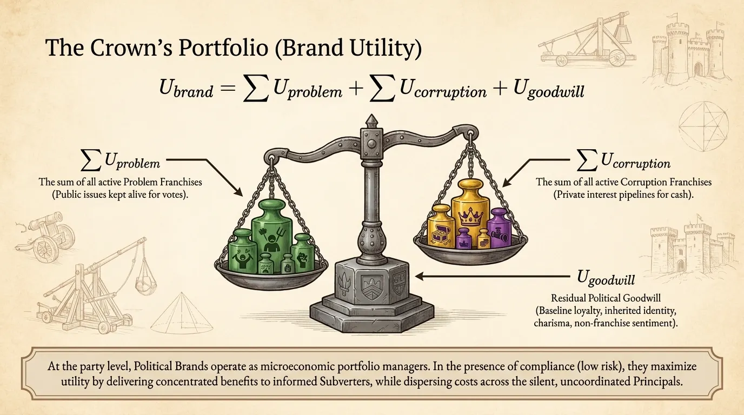
At the collective or party level, a political faction operates as a Political Brand, while several Political Brands can be present in a Political Camp. A camp is defined as an area of confinement, and the borders are defined by which issues you are allowed to express interest in.
In the presence of compliance, there is low Risk of the political franchise degrading over time and so politicians, the Agents, maximise Utility by delivering personal benefits to highly organised, well-informed special interest groups, the Subverters, at the expense of the silent, uncoordinated majority: the Principals.
This means that the Political Brands are managing Problem Franchises to maximise Utility from the voters, and they are managing Corruption Franchises to maximise Utility with the Subverters.
The equation for the Total Utility of a Political Brand (see diagram) is grounded in microeconomic portfolio theory and Capital Asset Pricing Models (CAPMs).
The same principles apply for all measures of Utility, and the equations all have the same underlying form. Utility, U, can either be measured in terms of Expected Cash Flow or Expected Votes. Expected Power and Expected Leisure are also reasonable metrics, but we will not be considering those other than pointing out that they affect the Utility of Goodwill, even in their own Utility Functions.
The Total Utility of a Political Brand is modelled as the sum of the Utility Contributions across all active Problem Franchises, across all active Corruption Franchises, and a residual Utility term for Political Goodwill.
The Utility of Goodwill changes very slowly in the real world, and accounts for Social Capital, delivery/failure to deliver on promises or reputation in general. Reputation and Social Capital cannot be separated from Power and Leisure. Power is the ability to enact your will without resistance and Leisure is how Stress-free the job of the politician is - both are assisted by a good reputation.
By viewing the political state through Public Choice Theory, we see that political brands are simply portfolio managers of competing utilities, maintaining a balance of Problem Franchises, Corruption Franchises, and baseline Goodwill to preserve, and hopefully grow their Brand.

Political Problem Franchises
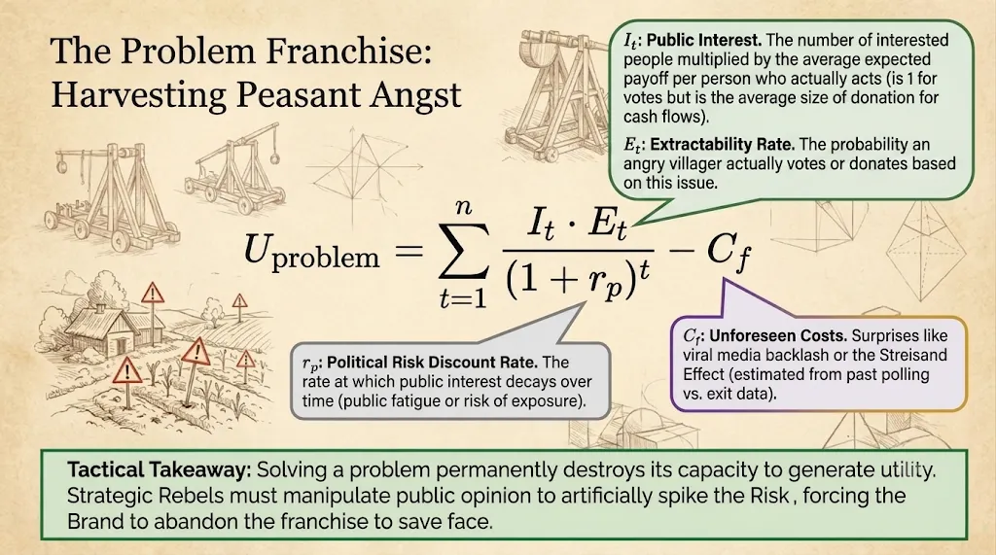
If a politician’s primary objective is the maximisation of Brand Utility, then a public interest issue or a crisis cannot be viewed as a problem to be resolved.
Solving a problem permanently destroys its capacity to generate political Utility. Therefore, in terms of a politician advancing his career, a public interest issue tends to be treated as a perpetual, vote-generating asset: a Problem Franchise.
The future value of a franchise is calculated using the Discounted Cash Flow equation. Just as a commercial enterprise evaluates the potential Utility of a franchise by Discounting its anticipated future Cash Flows, a Problem Franchise can be evaluated by discounting its net long-term vote and utility contributions.
We add an additional Cost term to account for unforeseen political influences. This can be estimated by looking at the difference between expected values, from polling statistics, and observed values in the past, or by other means.
Public Interest and Extractability Rate are inseparable from Public Opinion, and can be impacted positively or negatively using public awareness campaigns ranging from things like hash tag campaigns, in lightly-oppressed situations, to physical graffiti tag campaigns, in more heavily oppressed environments.
It is also within the power of a Strategic Rebel to impact the Risk associated with a Problem Franchise. If a Problem Franchise becomes too Risky, it incentivises the politicians to solve the problem, harvest the Goodwill, and move to safer Problem Franchises.
Unforeseen Costs are affected by things like viral media, the Streisand Effect, or any response by the Brand that has a costly effect on Public Opinion.

Political Corruption Franchises

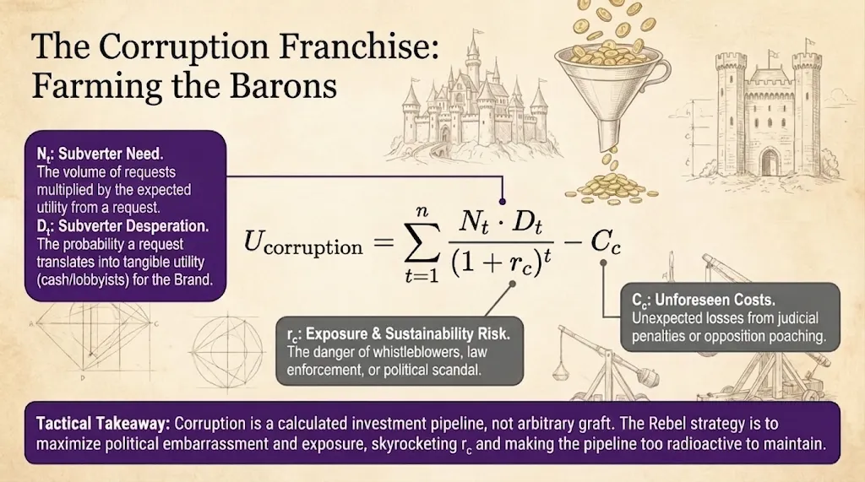
While a Problem Franchise harvests votes from public interest issues, a Political Brand also requires Finances to fund campaign infrastructure, media dominance, and its networks in general – the source of which is irrelevant.
This leads directly to the creation of a Corruption Franchise: a pay-for-play system established between political Agents and special interest groups, or Subverters.
Corruption cannot be evaluated merely as arbitrary graft or moral weakness. In political survival terms, it is a calculated investment ecosystem that converts Subverter demand and Subverter desperation directly into monetary cash flows or purchased vote yields.
The Subverter Need and Desperation are difficult to influence if you do not know about the corrupt dealings, emphasising the usefulness of Information Asymmetry.
However, if a Strategic Rebel is aware of a corrupt relationship then Need and Desperation can be manipulated by bringing the battle to the realm of Public Opinion. Even better, if one Subverter’s interests are in conflict with another Subverter, then that conflict should be exploited to drive up Friction Costs between Subverters.
The Ruler population does that the to the Ruled population in any way, but Game Theory for Rebels 4 will give an asymmetric counter-strategy based on Solution Franchise models.
A Strategic Rebel’s main angle of attack is in escalating the political Risk associated with each Subverter relationship, centred around one point of interest at a time. Only the Agent cares about political Risk, the Subverter has different calculations.
Unforeseen Costs are escalated through public awareness campaigns that are designed to maximise political embarrassment. Online censorship can be overcome by distributing stencils or designs for graffiti tags, promoting campaigns at locations that maximise political embarrassment.

Mechanics and Strategic Implications
of Political Franchises

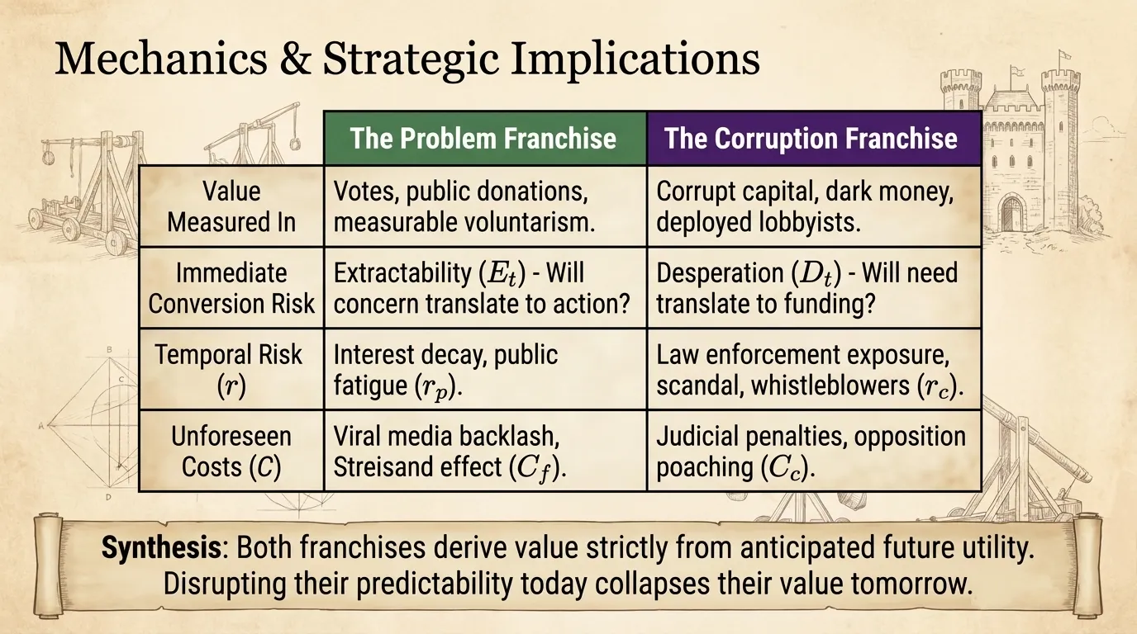
Both Problem and Corruption Franchises are governed by the same underlying Discounted Cash Flow dynamics. It therefore makes sense to consider the general implications of these models together.
Bear in mind that these Utility calculations do not take the past or present into account, other than for predicting Unforeseen Costs. The value of a franchise is almost entirely derived from its anticipated Utility in the future.

Utility as Votes, Cash Flows or Measurable Voluntarism:
Problem Franchises can be valued according to the number of votes, the amount of public and private donations, or the amount of volunteers that it is expected to generate or inspire.
Corruption Franchises can be valued according to the number of votes that are expected to be secured using corrupt capital, by any means legal or not, according to the size of the corrupt cash flow, or according to political benefit expected from Subverter activity such as the number of lobbyists the Subverter deploys to create quid-pro-quo relationships.

Dual Layers of Risk:
Both franchise equations distinguish between two fundamental dimensions of uncertainty:
- Immediate Conversion Risk:
The Extractability Rate represents the probability that an interested citizen actually translates concern into action, or that a Subverter Desperation successfully translates their Need into active support over time. Both franchise models sensitive to public exposure campaigns because of this.
- Temporal Attention and Risk Discounting:
The Risk Discount Rate is the main factor that determines how quickly a Problem Franchise collapses over time. High Risk reflects temporal interest decay, public fatigue, or rising risks of exposure and scandal.
The Utility of Corruption is significantly impacted by inflating the Risk associated with a Corruption Franchise.
Politicians are therefore forced to abandon Franchises for something more profitable if the Risk exceeds their tolerance.
Unforeseen Cost Inflation:
The Unforeseen Costs are estimated using past data alone, meaning that a Political Brand only finds out the impact of their moves later on in the game. This represents an enormous blind spot that a Strategic Rebel should try to exploit.
These Costs represent an estimate of net votes or financial support lost to opposition poaching, judicial penalties, or non-sentiment campaign tactics over an entire election cycle.
The less the expected value resembles the observed value of Unforeseen Costs, the less confidence the Political Brand has that it has assessed the Risks correctly.

The Principal-Agent-Subverter (PAS) Model

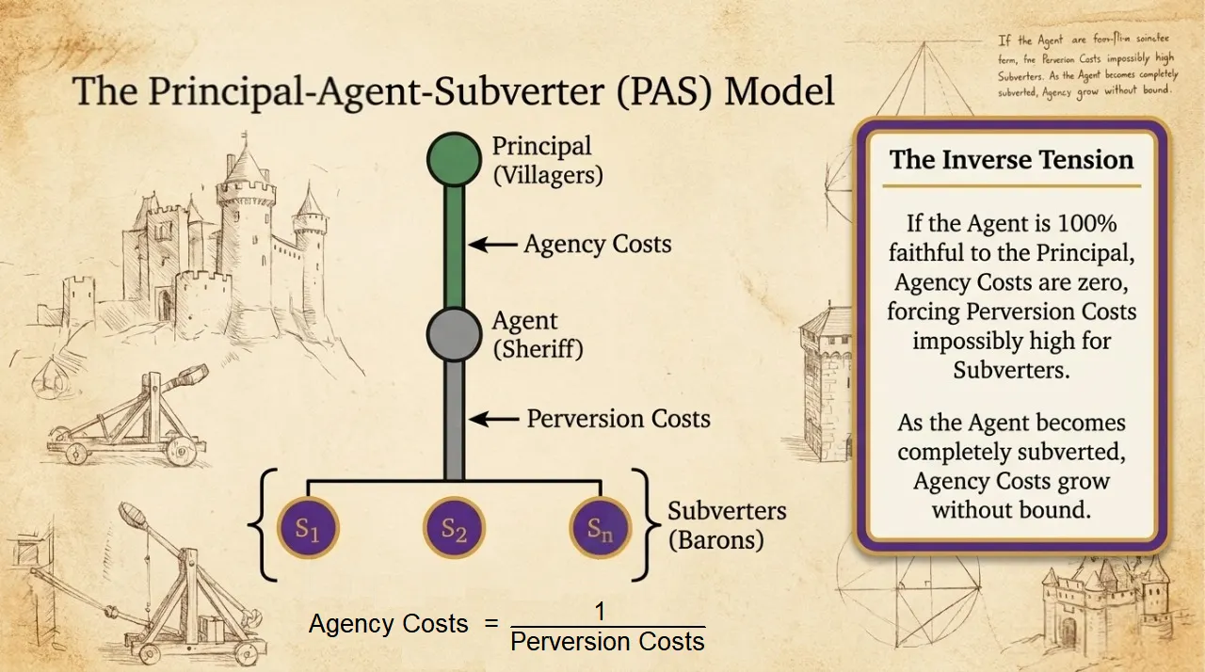
Because a Political Brand maintains both Problem Franchises and Corruption Franchises, the relationship between the voter, as Principal, and the politician, as Agent, cannot be modelled as a simple Principal-Agent Problem.
The standard Principal-Agent dynamic describes a relationship where the Principal delegates authority to the Agent to act on their behalf. Due to Information Asymmetry, the Agent has both the opportunity and the incentive to act upon Conflicts of Interest, generating Agency Costs that the Principal needs to bear.
The Principal-Agent-Subverter (PAS) model introduces a third Player: the Subverter. The Subverter represents special interest groups, oligarchs, lobbyists, or corporate syndicates that seek to get the Agent to act on their behalf, at the expense of the Principal.
The Subverter seeks to purchase policy outcomes at the expense of the Principal’s agenda, and pays Perversion Costs for the attempt. The Agent’s Conflict of Interest arises because they must balance the demands of the Principal against the resources of the Subverter.
The Problem Franchise is therefore associated with the Principal-Agent link, while the Corruption Franchise is associated with the Agent-Subverter link.
The core structural tension of the PAS model is defined by the inverse relationship of the extra Costs experienced by the Agent and the Subverter.
If the Agent is 100% faithful to the Principal, Agency Costs are zero. To force a Defection, the Subverter must pay an impossibly high price in bribes, campaign matches, or reputational risks. On the other hand, as the Agent becomes completely subverted, Agency Costs to the Principal grows without bounds. Perversion Costs are therefore inversely proportional to Agency Costs.
A Strategic Rebel therefore needs to maximise Perversion Costs to ensure that the politicians are predominantly working in the interest of the public.

The Median Trade-Off Theorem

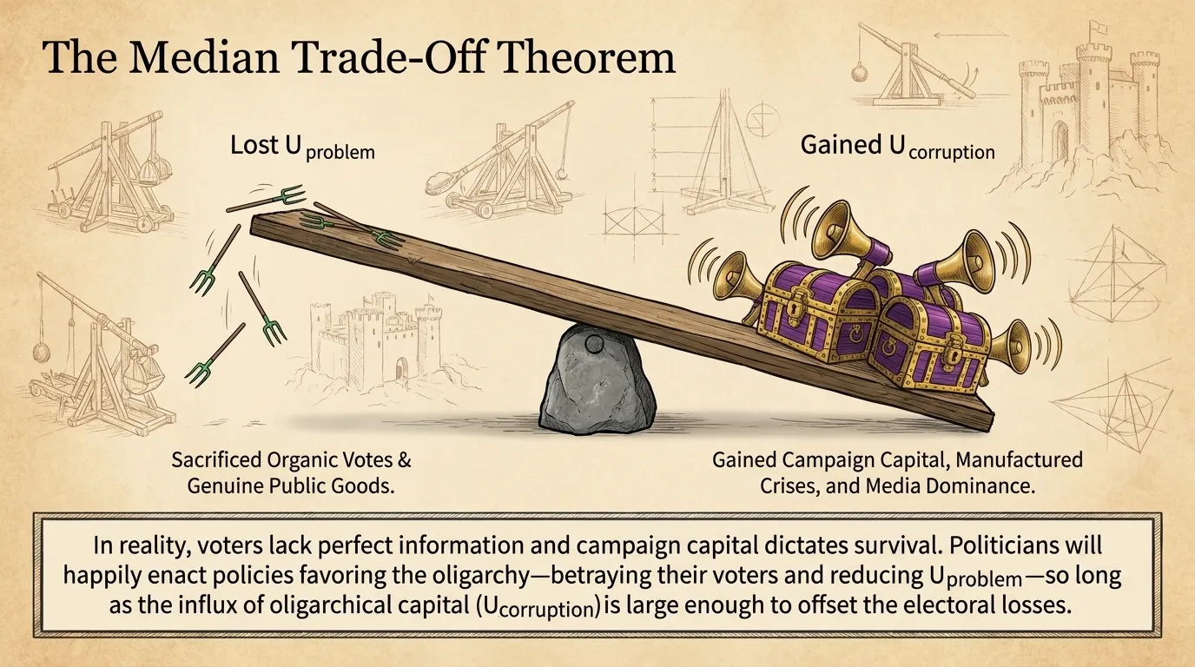
We can recontextualise the Median Voter Theorem to explain how Political Brands survive elections if they are constantly betraying the public to serve the Subverters.
The Median Voter Theorem suggests that in a majority-rule system, political parties will converge on the preferences of the median voter to secure a majority, which is why politicians flip-flop on issues.
In reality, the Agent faces a Median Trade-Off of contributions to Brand Utility. They must balance three distinct sources of electoral power.

Utility of Problem Franchise:
Political leverage secured through addressing or exploiting genuine public grievances, delivering visible public goods, and maintaining baseline alignment with the Principal.

Utility of Corruption Franchise:
Political leverage secured through manufactured crises, proprietary technological or policy solutions, targeted narrative manipulation, and media dominance, financed by the oligarchy’s capital.

Utility of Goodwill:
Political leverage arising from public attitudes and brand reputation. It is affected by whether or not promises are kept, which we know has a minimal effect compared to the above.
We can ignore the Utility of Goodwill if we assume that it remains more or less stable, and only the Problem and Corruption Franchises are being actively maintained. Nevertheless, if a Strategic Rebel undermines a Problem or Corruption Franchise, this should also have a negative effect on Goodwill.
This explains why politicians will happily betray the voters. Reducing the Utility of Problem Franchises by enacting policies that favor the oligarchy is acceptable as long as the gain in Utility of the Corruption Franchises is large enough to offset the Costs.
If we can collapse the dynamics of Problem and Corruption Franchises, the only means of Utility maximisation left to politics is the optimisation of Goodwill, which implies delivering on promises and having healthy policies that visibly improve the quality of life for the poorest citizens, and therefore for the average citizen.
If Strategic Rebels can build independent information networks and make appropriate use of public tagging, including advertisements, then exposing the existence and mechanisms of the corruption franchises is your most powerful tool. Expect censorship.
We can look to the Multi-Subverter Model for a better understanding of how to interfere with Corruption Franchises and oligarchical collusion.

The Multi-Subverter Model and Cartel Friction

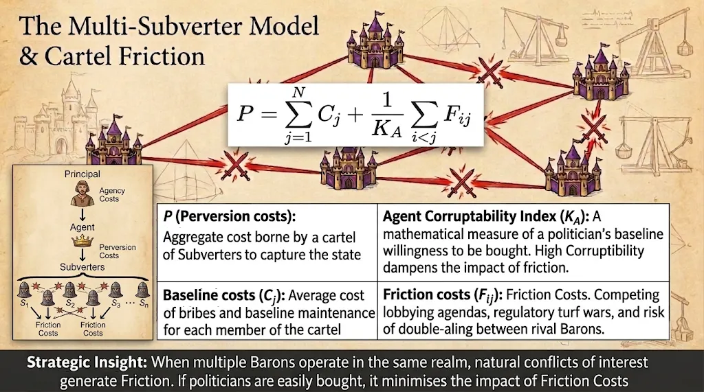
In any realistic political ecosystem, the Agent does not interact with a single, monolithic Subverter. Instead, the Agent faces a landscape of multiple Subverters operating either as isolated competitors or as an Oligarchy, a collusive coalition of wealthy special interests.
To minimise Perversion Costs, Subverters need to minimise Friction Costs and maximise a variable called the Corruptibility Index of the Agent, which measures the impact of Agent attitudes on the conversion of Friction Costs into Perversion Costs.
When multiple Subverters operate in the same environment, natural Conflicts of Interests will generate Friction Costs between any pair of Subverters, i and j. These Friction Costs can take the form of competing lobbying agendas, regulatory turf wars, legal disputes, or the risk of double-dealing by the Agent, etc.
The Corruptibility Index of the Agent serves as an explicit mathematical measure of how receptive, accommodating, and compliant a politician or institution is to Subversive Capture.
On the other hand, the easiest way to escalate costs for the Subverters is to lower the Corruptibility of your Agents, and this requires Mechanism Design to impose heavy, guaranteed costs in order to escalate the associated Risks of corruption.

Rent-Seeking, Oligarchy, and Factional Drift

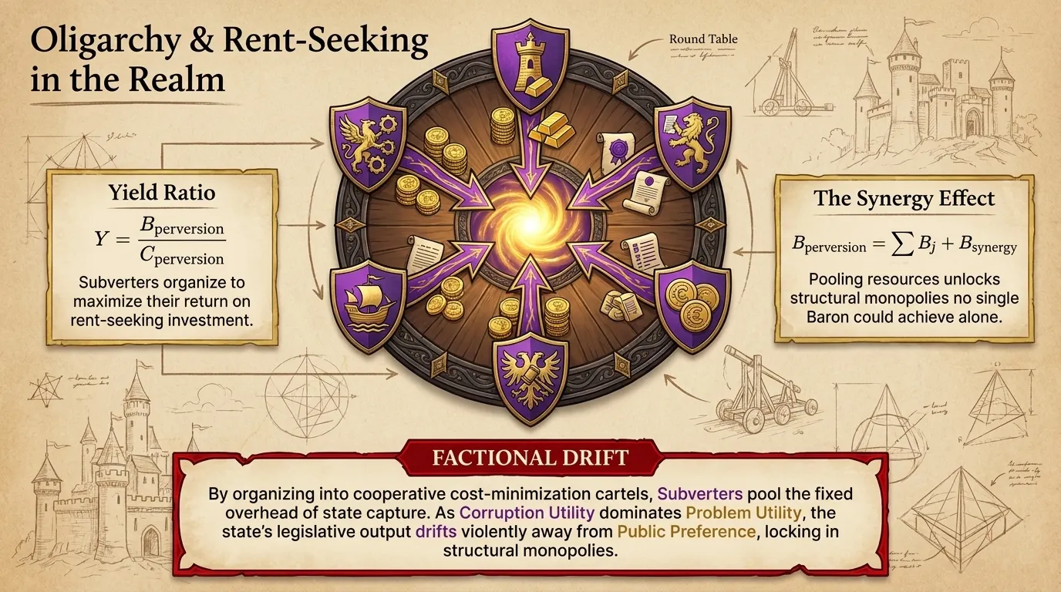
The Perversion Costs of Subverters are expenditures on Rent-Seeking: the practice of manipulating public policy or regulatory environments to redistribute existing wealth rather than creating new wealth.
The Subverter evaluates these expenditures through a Cost/Benefit Analysis. To maximise the Yield Ratio, Subverters organise into an Oligarchy: a cooperative cost-minimisation cartel designed to pool the fixed overhead of state capture.
Cartels minimise Perversion Costs because Subverters can share information on which Agents are already compromised, or can get their existing Agents to push the same agenda rather than buying more influence.
Collaboration also allows special interest factions to attempt strategic achievements far larger than any single actor could reach independently, such as comprehensive national regulatory capture, industry-wide price-fixing shields, or structural monopoly guarantees. We refer to this as the Benefit of Synergy.
If the Utility of the Corruption Franchises begin to dominate the Utility of the Problem Franchises, the legislative output of the state drifts further away from Public Preference, giving rise to Factional Drift as the political Brands reorient their priorities.
Since the power of Oligarchy lies in its synergy, the Strategic Rebel’s main point of attack is therefore to escalate Friction Costs by identifying and then exacerbating wedge issues between oligarchs.
Oligarchs have a monetary bottom line, which is why disruptive movements like Occupy Wall Street scare them. By attacking their Information Asymmetry, we lower the Agency Costs experienced by the general public, thus maximising the Perversion Costs endured by the Oligarchs.

The (Mechanistic) Truth Shall Set You Free

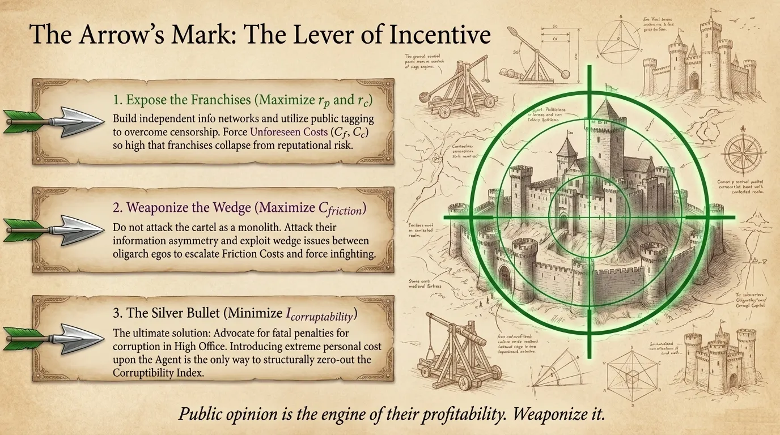
A politician can derive Utility from both legal and illegal means, and there is a Median Trade-Off where the politician balances the risk and potential benefits of various scenarios and then goes with the options that advance their own careers.
Corruption is therefore an inevitable dynamic that is a natural consequence of Public Choice Theory.
In order to maximise the Perceived Value of society for both the Ruler and the Ruled populations, Agency Costs have to be minimised and Perversion Costs need to be maximised.
The aim of Strategic Rebellion should be to force the Rulers to accept a Constitutional change where Game Theory and Mechanism Design is used to introduce strong personal Costs upon the Agent for interacting with a Subverter.
We need to force a Social Contract where our leaders are just ordinary citizens that are held accountable for not doing their job, and in a manner that is proportional to the gravity of their responsibilities, because this maximises the Perceived Value of society for both Ruler and Ruled populations.
If history has taught us one lesson, it is that we are foolish as a species not to introduce the death penalty for Corruption in High Office. The impact that this has on the risk of a Corruption Franchise makes it the closest thing that society has to a silver bullet against the formation of oppressive regimes.
Since we do not have that, our best approach is to maximise the Friction Costs between oligarchs by looking for wedge issues that can be used as an attack on their egos.
The most important revelation of this section is that Public Opinion is what makes political Problem and Corruption Franchises profitable.
If Public opinion can be used to minimise Utility of Problem and Corruption Franchises, then politicians will be forced to maximise the Utility of Goodwill by delivering meaningful Benefits to the general public.

